CSE212

SOFTWARE DEVELOPMENT METHODOLOGIES

SPRING 2024

LABWORK 4 - SECTION 1 & 2

Below, you can find the description of your labwork for today. You can also find the expected output of this code in the Application Walkthrough section.

You are going to improve your Rental System on top of your previous week’s labwork by incorporating inheritance hierarchy.

You should add two new classes called Content and DigitalMovie. *Content* should be the **superclass** of DVD and DigitalMovie classes. Thus, you should define the common variables such as title and artist in the Content class. Also, you need to modify some of your existing classes as shown below. Notice the addition of new variables and methods.

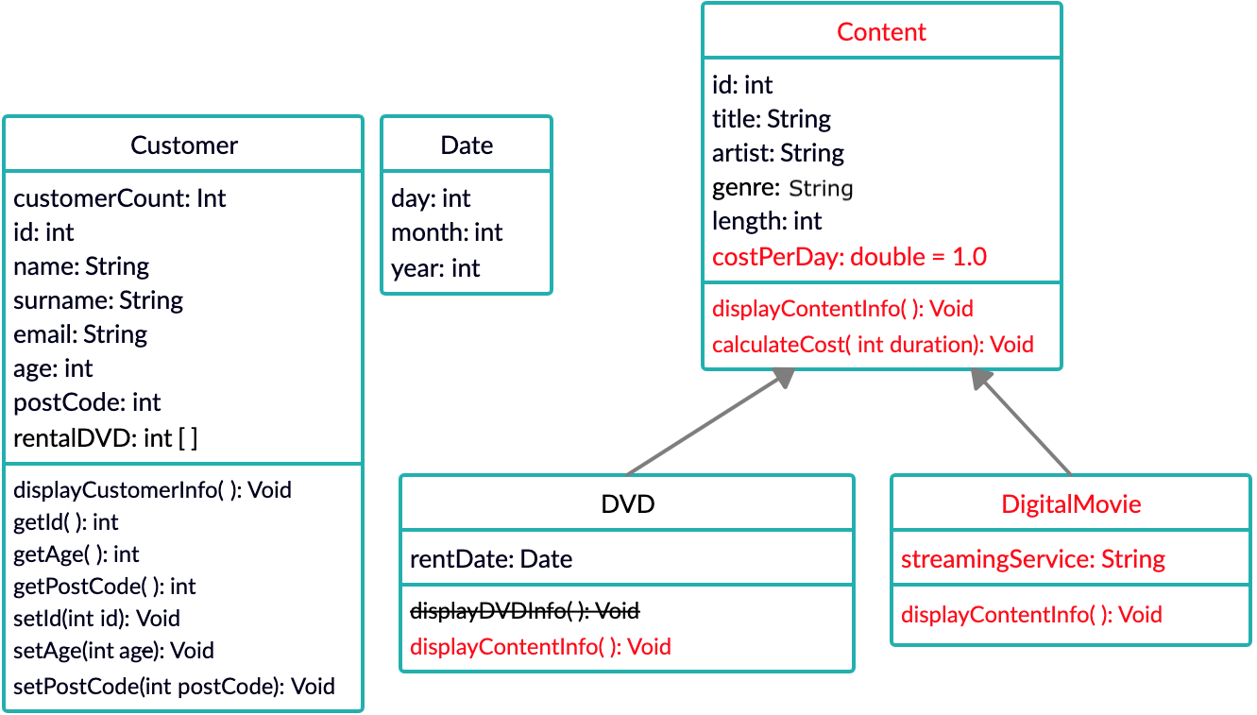

You should define the *displayContentInfo()* method in Content, DigitalMovie and DVD classes. This method should display the needed information in the context of the proper class. For example, *id*, *title*, *artist*, *genre* and *length* information should be printed the same in every subclass of Content. Then you can use the displayContentInfo() in *Content* class to print that information.

You should also override the displayContentInfo()method in the subclasses of Content class (and also use the overridden method in superclass). So when you call this method, every information either defined in superclass or subclass must be displayed properly.

The calculateCost() method in Content class is used when displaying content information. Method should return the daily payment by multiplying cost per day worked with the duration itself (costPerDay*duration).

When user starts your application, it should prompt the user with the following menu:

1. Create a new Customer

2. Create a new DVD

3. Create a new DVD with genre

4. **Create a new Digital Movie**

5. Rent a DVD

6. Display Customer information

7. **Display Content information**

8. Display number of customers.

0. Exit

**Application Walkthrough**

1. Create a new Customer

2. Create a new DVD

3. Create a new DVD with genre

4. Create a new Digital Movie

5. Rent a DVD

6. Display Customer Information

7. Display Content Information

8. Display number of customers.

0. Exit

1

Enter id

1000

Enter name

John

Enter surname

Blake

Enter age

34

Enter postal code

34724

Enter email

[johnblake@gmail.com](mailto:johnblake@gmail.com)

1. Create a new Customer

2. Create a new DVD

3. Create a new DVD with genre

4. Create a new Digital Movie

5. Rent a DVD

6. Display Customer Information

7. Display Content Information

8. Display number of customers.

0. Exit

1

Enter id

1001

Enter name

Mary

Enter surname

Jane

Enter age

20

Enter postal code

34555

Enter email

[mary_jane@yahoo.com](mailto:mary_jane@yahoo.com)

1. Create a new Customer

2. Create a new DVD

3. Create a new DVD with genre

4. Create a new Digital Movie

5. Rent a DVD

6. Display Customer Information

7. Display Content Information

8. Display number of customers.

0. Exit

2

Enter id

10

Enter title

The Lord of the Rings: The Fellowship of the Ring

Enter artist

Elijah Wood

Enter length

178

1. Create a new Customer

2. Create a new DVD

3. Create a new DVD with genre

4. Create a new Digital Movie

5. Rent a DVD

6. Display Customer Information

7. Display Content Information

8. Display number of customers.

0. Exit

3

Enter genre

Thriller

Enter id

11

Enter title

Parasite

Enter artist

Song Kang-ho

Enter length

132

1. Create a new Customer

2. Create a new DVD

3. Create a new DVD with genre

4. Create a new Digital Movie

5. Rent a DVD

6. Display Customer Information

7. Display Content Information

8. Display number of customers.

0. Exit

4

Enter id

12

Enter title

Spenser Confidential

Enter artist

Mark Wahlberg

Enter length

111

Enter streaming service:

Netflix

1. Create a new Customer

2. Create a new DVD

3. Create a new DVD with genre

4. Create a new Digital Movie

5. Rent a DVD

6. Display Customer Information

7. Display Content Information

8. Display number of customers.

0. Exit

5

Enter customer id

1000

Enter DVD id

10

Enter day

7

Enter month

2

Enter year

2020

1. Create a new Customer

2. Create a new DVD

3. Create a new DVD with genre

4. Create a new Digital Movie

5. Rent a DVD

6. Display Customer Information

7. Display Content Information

8. Display number of customers.

0. Exit

6

Enter customer id

1000

id:1000

name:John

surname:Blake

age:34

postal code:34724

email:johnblake@gmail.com

1. Create a new Customer

2. Create a new DVD

3. Create a new DVD with genre

4. Create a new Digital Movie

5. Rent a DVD

6. Display Customer Information

7. Display Content Information

8. Display number of customers.

0. Exit

7

Enter Content id

12

id:12

title:Spenser Confidential

artist:Mark Wahlberg

genre:Other

length(in minutes):111

Streaming Service:Netflix

How long would you like to rent that Digital Movie?

5

The rental cost for 5 days is $5.0

1. Create a new Customer

2. Create a new DVD

3. Create a new DVD with genre

4. Create a new Digital Movie

5. Rent a DVD

6. Display Customer Information

7. Display Content Information

8. Display number of customers.

0. Exit

7

Enter Content id

11

id:11

title:Parasite

artist:Song Kang-ho

genre:Thriller

length(in minutes):132

How long would you like to rent that DVD?

3

The rental cost for 3 days is $3.0

1. Create a new Customer

2. Create a new DVD

3. Create a new DVD with genre

4. Create a new Digital Movie

5. Rent a DVD

6. Display Customer Information

7. Display Content Information

8. Display number of customers.

0. Exit

0